**Project Design Phase-II**

**Technology Stack (Architecture & Stack)**

| Date | 29 October 2023 |
| --- | --- |
| Team ID | Team-592681 |
| Project Name | Early Diagnosis Of Diseases Using Image processing Of Human Nails |
| Maximum Marks | 4 Marks |

**Technical Architecture:**

The Deliverable shall include the architectural diagram as below and the information as per the table1 & table2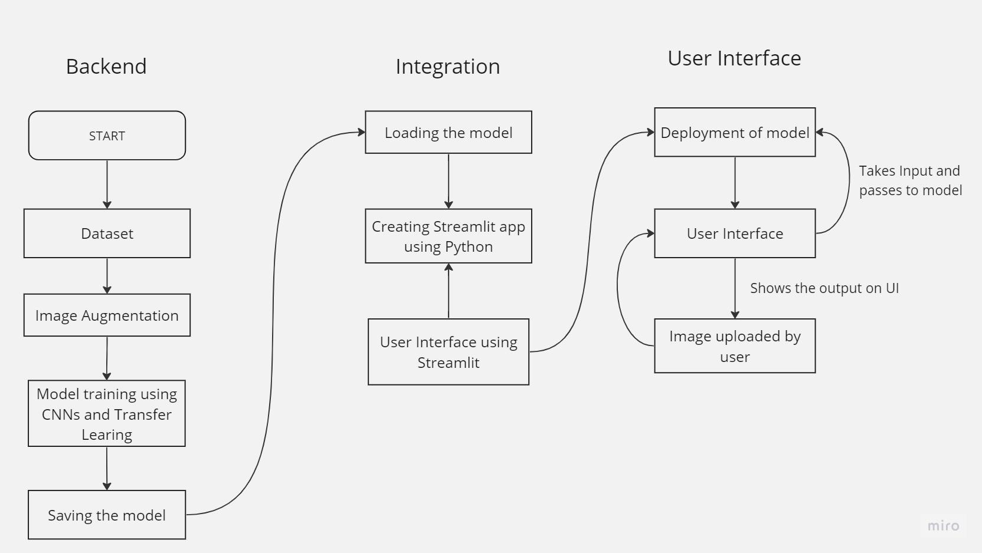

**Table-1 : Components & Technologies:**

| **S.No** | **Component** | **Description** | **Technology** |
| --- | --- | --- | --- |
| 1. | User Interface | How user interacts with application | Streamlit |
| 2. | Application Logic-1 | Used to make augment images and train out model | Python |
| 3. | Database | Collecting Dataset based on the problem statement | File Manager |
| 4. | File Storage /Data | File storage requirement for storing data | Local system, Google Drive |
| 5. | Framework | Used to Create a web Application, Integrating Frontend and Back End | Streamlit |
| 6. | Deep Learning Model | Purpose of Deep Learning Model | Object classification using CNNs and Transfer Learning |
| 7. | Infrastructure (Server / Cloud) | Application Deployment on Local System / Cloud Local Server Configuration:  Cloud Server Configuration : | Local, Cloud Foundry, Kubernetes, etc. |

**Table-2: Application Characteristics:**

| **S.No** | **Characteristics** | **Description** | **Technology** |
| --- | --- | --- | --- |
| 1. | Open-Source Frameworks | List the open-source frameworks used | Streamlit |
| 2. | Security Implementations | List all the security / access controls implemented, use of firewalls etc. | e.g. SHA-256, Encryptions, IAM Controls, OWASP etc. |
| 3. | Scalable Architecture | Justify the scalability of architecture (3 – tier, Micro-services) | Technology used |

| **S.No** | **Characteristics** | **Description** | **Technology** |
| --- | --- | --- | --- |
| 4. | Availability | Justify the availability of application (e.g. use of load balancers, distributed servers etc.) | Technology used |
| 5. | Performance | Design consideration for the performance of the application (number of requests per sec, use of Cache, use of CDN’s) etc. | Technology used |

**References:**

**https://c4model.com/**

**https://developer.ibm.com/patterns/online-order-processing-system-during-pandemic/**

**https://www.ibm.com/cloud/architecture**

**https://aws.amazon.com/architecture**

**https://medium.com/the-internal-startup/how-to-draw-useful-technical-architecture-diagrams-2d20c9fda90d**